
CpE-371: SOFTWARE ENGINEERING AND DEVELOPMENT



Campus Room & Equipment Booking System
Software Requirements Specification (SRS)

Version | V1
Status | Finalized
Date | 2026-04-26
Prepared by | Yousof Dardir, 2211136883  Yousef Alotaibi , 2221160110  Naif Alhariji, 2221160320

Department of Computer Engineering
College of Engineering and Petroleum
Kuwait University
2025 - 2026

Signature Page
I did my share of the work, and I have a general understanding of the contents of the assignment
Name Signature
Yousof Dardir

Yousef Alotaibi

Naif Alhariji

Report Evaluation
Criterion | Evidence / focus | Weight | Marks | Comments
Document control & professionalism | Version history, ownership, formatting, completeness | 5
Introduction & project framing | Purpose, scope, vision, constraints, assumptions, stakeholders | 10
Functional requirements | Clear, grouped, numbered, testable 'shall' statements | 15
Use-case model | Diagram, actors, use-case specs, traceability, coverage | 15
Non-functional requirements | Measurable NFRs with verification method | 10
Domain / data model | Domain overview, ERD/model, retention/deletion/auditability | 10
UI prototype & usability | Scenario coverage, key screens, findings, updates | 10
Project management & evidence | WBS, Gantt, refs, repo links, meeting records | 5
Team Deliverable Quality (Total) |  |  |  | out of 80
Individual Grade (20%)
Student name | Avg peer score  (/28) | Adjustment | Final mark  (/100) | Notes

Table of Contents
Contents
1
1. Document Control 7
1.1 Version history 7
1.2 Credits 7
1.3 Related documents / links 7
2. Introduction 8
2.1 Purpose 8
2.2 Product vision 8
2.3 Scope 8
2.4 Assumptions and dependencies 9
2.5 Constraints 9
2.6 Stakeholder summary 10
2.7 Overview 10
3.1 Functional requirements 11
3.2 Use Case Model 12
4. Non-functional Requirements 15
5. Domain overview 17
5.2 Entity-relationship diagram (ERD) / domain model 18
5.3 Data retention, deletion, and auditability 19
6. UI Prototype and Usability Evaluation 20
6.1 Prototype link 20
6.2 Key screens and states 20
7. Appendix 24
7.1 References 24
7.2 Project Management 24
Work Breakdown Structure 24
Gantt Chart 25
Team Meetings 26
Summary of meeting 1 26
Summary of meeting 2 27
Summary of meeting 3 28

List of Abbreviations
Abbreviation | Meaning
SRS | Software Requirements Specification
UI | User Interface
ERD | Entity-Relationship Diagram
NFR | Non-Functional Requirement
FR | Functional Requirement
UML | Unified Modeling Language
WBS | Work Breakdown Structure
API | Application Programming Interface

Glossary
Term | Definition
Booking | A reservation made by a user for a room or equipment at a specific time
User | Any person who interacts with the system (student, staff, or administrator)
Administrator | A user with permissions to approve, reject, or manage bookings
Resource | A room or equipment that can be reserved
No-show | A situation where a user does not attend a confirmed booking
Audit Log | A record of system actions such as booking creation, approval, or cancellation
Policy | Rules that control booking behavior (e.g., time limits, permissions)
Availability | The status of a room or equipment indicating whether it can be booked

1. Document Control

1.1 Version history
Version | Date | Authors | Change summary | Approval
0.1 | 2026-03-31 | Yousof Dardir, Yousof Alotaibi, Naif Alhariji | Section 1, Section 2, Section 3 | Approved by team
0.2 | 2026-04-12 | Yousof Dardir | Section 4 | Approved by team
1.0 | 2026-04-26 | Yousof Dardir, Yousof Alotaibi, Naif Alhariji | Final version including completed document control, domain model, UI prototype and project management evidence | Approved by team

1.2 Credits
Name | Role/Task
Yousef Alotaibi | Section 1 – Document Control (Version History, Credits, Related Documents)
Naif Alhariji | Section 2 – Introduction (Purpose, Vision, Scope, Stakeholders, Constraints)
Yousof Dardir | Section 3 – Functional Requirements and Use-case Model
Yousef Alotaibi | Section 5 – Domain Model: domain overview, domain model diagram, data retention, deletion, and auditability.
Naif Alhariji | Section 6 – UI Prototype and Usability Evaluation.
Yousof Dardir | Section 7 – Appendix and Project Management: references, WBS, Gantt chart, repository link, and meeting records.

1.3 Related documents / links
- https://github.com/YousofDardir/Software-Project
- https://www.figma.com/design/wywsUK3Lp4815LHvNMfuIM/Project?node-id=0-1&m=dev&t=f29dk7ybKl9GWvKs-1
- https://www.onlinegantt.com/#/gantt

2. Introduction

2.1 Purpose
This Software Requirements Specification (SRS) document describes the requirements, functionalities, and constraints of the Campus Room & Equipment Booking System. The purpose of this document is to provide a clear and shared understanding of the system for the development team, instructor, and stakeholders. It serves as a reference for design, implementation, and testing to ensure that the system meets the required specifications and user needs. The system is constrained by university policies, including restricted access to certain rooms and limited booking durations.

2.2 Product vision

The Campus Room & Equipment Booking System aims to simplify and automate the process of reserving campus rooms and equipment. It allows students and staff to easily search availability, request bookings, and manage reservations. The system improves efficiency by reducing manual coordination, preventing booking conflicts, and providing a structured approval process managed by administrators

2.3 Scope
In scope:
- Search availability of rooms and equipment
- Create booking requests (who, what, when, why)
- Apply policy checks (time limits, permissions, rules)
- Admin approval or rejection of requests
- Booking confirmation and audit tracking
- Modify or cancel reservations
Out of scope / non-goals:
- Integration with physical hardware (e.g., smart locks)
- Advanced AI scheduling optimization
- External system integrations beyond basic scope

2.4 Assumptions and dependencies
Assumptions:
- Users have valid university accounts
- Users have access to internet
- Booking data is accurate and up to date
Dependencies:
- Internet connectivity
- Database system for storing bookings
- Authentication system for users

2.5 Constraints
- Time constraint: limited to semester duration
- Technology constraint: system will be developed using course-approved tools
- Operational constraint: system runs on standard web or mobile platforms
- Policy constraint: booking rules must follow university regulations

2.6 Stakeholder summary
Role | Primary goals | Key needs / pain points | Priority (H/M/L)
Student / Requester | Quickly find and book available rooms or equipment | Needs a simple interface, accurate availability, and fast booking process | High
Staff / Faculty | Manage and reserve rooms/resources for academic purposes | Needs flexible booking options and fewer restrictions compared to students | High
Facilities Admin | Oversee and control all bookings, enforce policies | Needs full control, conflict resolution tools, and clear approval workflows | High
Instructor | Evaluate the system and ensure requirements are met | Needs clear documentation and well-structured system design | Medium

2.7 Overview
This document is organized as follows: Section 3 presents the functional requirements and use-case model. Section 4 describes the non-functional requirements. Section 5 explains the domain model. Section 6 covers the UI prototype and usability evaluation. Finally, Section 7 includes references and project management details. 3. Functional Requirements and Use-case Model

3.1 Functional requirements
FR-01: Booking Management
1.1 Search Availability: The system shall allow users to search for available rooms and equipment based on date, time, and type.
The system shall display a message if no rooms or equipment are available for the selected criteria.
The system shall validate input values such as date and time before performing the search.
Edge case: If the user selects a past date, the system shall display an error message.
If no matching results are found, the system shall clearly indicate that no resources are available.
1.2 Create Booking Request: The system shall allow users to submit a booking request by selecting room, time slot, and required equipment. Reject overlapping bookings and incomplete input.
The system shall validate that all required fields (room, date, time, and user information) are provided before submitting the request.
The system shall reject booking requests with invalid time ranges (e.g., end time before start time).
Edge case: If the selected time slot overlaps with an existing booking, the system shall reject the request. If the booking exceeds the maximum allowed duration, the system shall display an error message.
1.3 View Booking Status: The system shall allow users to view the status of their booking requests (pending, approved, rejected).
FR-02: Booking Administration
2.1 Review Requests: The system shall allow administrators to view all booking requests submitted by users.
2.2 Approve/Reject Requests: The system shall allow administrators to approve or reject booking requests. The system shall prevent approving a request if the room becomes unavailable.
The system shall validate that the booking is still available before approval.
Edge case: If the booking was already approved or cancelled, the system shall prevent duplicate actions. If two admins try to approve the same request, the system shall allow only one approval.
2.3 Manage Bookings: The system shall allow administrators to modify or cancel existing bookings when necessary.
FR-03: No-Show Handling (Extension H)
3.1 Detect No-Show: The system shall mark a booking as a no-show if the user does not check in within the allowed time. The system shall not mark a booking as no-show if the user checks in within the allowed grace period
3.2 Notify User: The system shall notify the user when their booking is marked as a no-show.
3.3 Apply Penalty: The system shall apply penalties (such as warnings or temporary restrictions) for repeated no-shows.
The system shall validate check-in time against the allowed grace period.
Edge case: If the user checks in late but within the grace period, the system shall not mark the booking as no-show.
If a user accumulates multiple no-shows, the system shall restrict future bookings.

3.2 Use Case Model

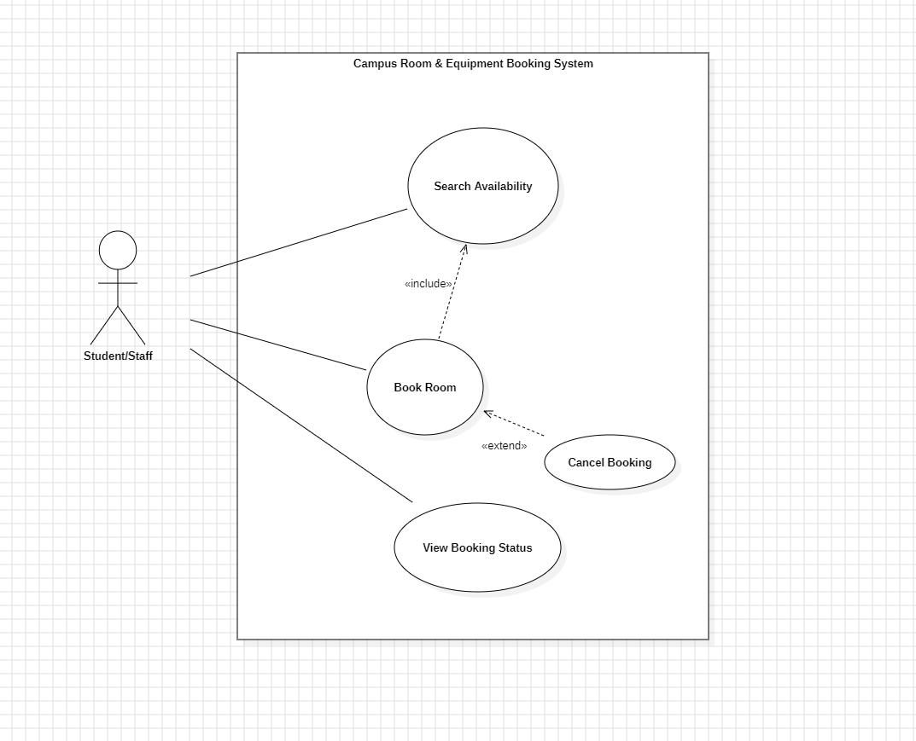
Figure 1 Use Case Diagram

Use case UC-1: Book Room
Related Requirements | FR-01 (1.1, 1.2, 1.3)
Description (Goal) | The user wants to search and book a room for a specific time.
Primary Actor(s) | Student / Staff
Secondary Actor(s) | System
Preconditions | User is logged into the system
Post-conditions | Booking request is submitted and stored in the system
Related use cases | Approve Booking
Basic Flow | User searches for available rooms  System displays available options  User selects room and time  User submits booking request  System saves request and sets status to “pending”
Alternative Flow | If no rooms are available → system displays message “No availability”

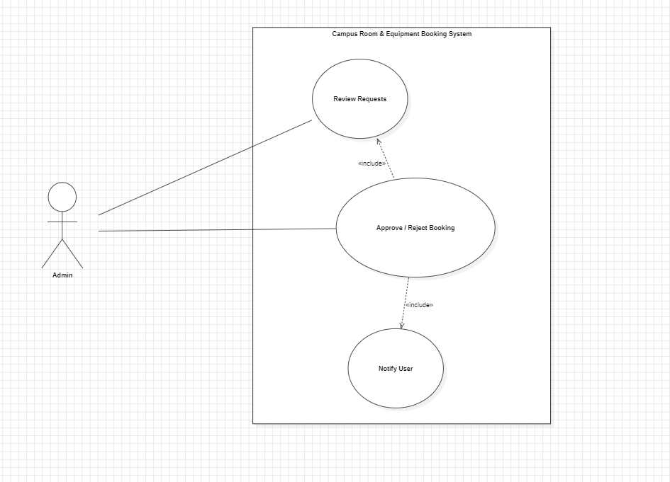
Figure 2 Use Case Diagram

Use case UC-2: Approve Booking
Related Requirements | FR-02 (2.1, 2.2, 2.3)
Description (Goal) | The administrator reviews and decides on booking requests.
Primary Actor(s) | Admin
Secondary Actor(s) | System
Preconditions | Booking request exists
Post-conditions | Booking is approved or rejected
Related use cases | Book Room
Basic Flow | Admin views booking requests  Admin selects a request  Admin approves or rejects request  System updates booking status  System notifies user
Alternative Flow | If request is invalid → system rejects automatically

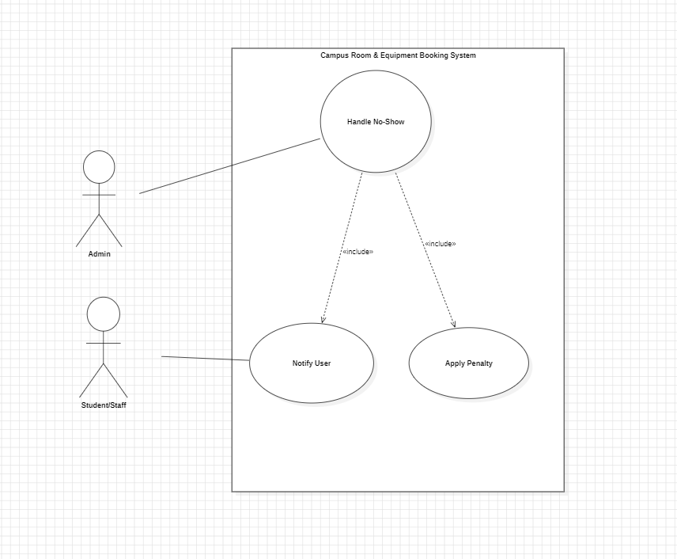
Figure 3 Use Case Diagram

Use case UC-3: Handle No-Show
Related Requirements | FR-03 (3.1, 3.2, 3.3)
Description (Goal) | The system detects and handles users who do not attend their bookings.
Primary Actor(s) | System / Admin
Secondary Actor(s) | User
Preconditions | Booking is approved  Booking time has passed
Post-conditions | Booking marked as no-show  Penalty may be applied
Related use cases | Approve Booking
Basic Flow | System checks booking at scheduled time  If user does not check in → mark as no-show  System updates booking status  System notifies user  System applies penalty if needed
Alternative Flow | If user checks in → booking continues normally (no penalty)

4. Non-functional Requirements
NFR-01: Performance
1.1 Response Time: The system shall display search results for available rooms and equipment within 3 seconds for 95% of requests under normal operating conditions.
Verification: Performance test.
Justification: Fast search results are important because users need to quickly find available rooms or equipment without delays, especially during busy university periods.
NFR-02: Reliability and Availability
2.1 System Availability: The system shall be available at least 99% of the time during official university working hours, excluding scheduled maintenance.
Verification: Monitoring and analysis.
Justification: The system must be reliable during university working hours because students and staff depend on it to manage scheduled bookings.
NFR-03: Privacy and Ethics
3.1 Personal Data Protection: The system shall store only the personal data necessary for booking and approval processes, such as user ID, name, role, and reservation details.
Verification: Inspection.
3.2 Privacy of User Information: The system shall ensure that reservation details and user information are visible only to authorized users involved in the booking, approval, or administration process.
Verification: Inspection and test.
Justification: Booking information may include personal and academic-related data, so access must be limited to authorized users only.
NFR-04: Usability
4.1 Ease of Use: The interface shall allow a user to complete a standard booking request in no more than 5 steps and with no more than 3 minutes of interaction for a first-time user.
Verification: Usability test.
Justification: A simple interface reduces user mistakes and allows first-time users to complete bookings without needing training.
NFR-05: Security
5.1 Authentication: The system shall require all users to log in using their university credentials before accessing booking functions.
Verification: Test.
5.2 Secure Data Handling: The system shall protect reservation and account data from unauthorized modification or deletion.
Verification: Test and inspection.

5.3 Access Control: The system shall enforce role-based access control so that students can create and manage their own requests, while facilities administrators can approve, reject, and manage all reservation requests.
Verification: Test.
Justification: Role-based access is needed to prevent normal users from approving bookings, editing resources, or viewing other users’ private requests.
NFR-06: Maintainability
6.1 Modular Design: The system shall be developed in a modular way so that changes to booking rules, room data, or equipment data can be made without affecting the whole system.
Verification: Inspection.
6.2 Ease of Update: The system shall allow administrators to update room, equipment, and policy information within 10 minutes without requiring source code changes.
Verification: Inspection and test.
Justification: Booking rules, room details, and equipment availability may change each semester, so the system should be easy to update.

5. Domain overview

Main users:
The main users of the system are students, staff/faculty, and facilities administrators. Students and staff can search for available rooms or equipment and submit booking requests. Facilities administrators can review these requests, approve or reject them, and manage booking conflicts.
Main domain objects:
The main domain objects in the system are User, Room, Equipment, Booking, Policy, No-Show Record, and Audit Log. A user represents a person who uses the system, such as a student, staff member, or administrator. A room represents a campus space that can be reserved, such as a classroom, lab, or meeting room. Equipment represents items that may be booked with a room, such as a projector, camera, or microphone.
Booking:
A booking represents a reservation request made by a user. Each booking includes details such as the selected room, requested equipment, date, start time, end time, reason for booking, and booking status. The booking status may be pending, approved, rejected, cancelled, completed, or no-show. Before a booking is approved, the system checks that there is no double-booking, the user has permission to book the selected room or equipment, and the requested time follows the allowed booking limits.
Policy:
A policy represents the rules used by the system to control bookings. These rules may include maximum booking duration, permission requirements, cancellation deadlines, and equipment usage rules. The administrator is responsible for applying and managing these policies.
No-show handling:
The system also keeps records for no-show handling. If a user does not check in within the allowed grace period, the booking may be marked as a no-show. Repeated no-shows may lead to warnings or temporary booking restrictions.
Audit log:
The system keeps an audit log for important actions. This includes creating a booking request, approving or rejecting a request, modifying a booking, cancelling a booking, marking a booking as no-show, and applying a penalty. The audit log helps the administrator review system activity and track who performed each action and when it happened.

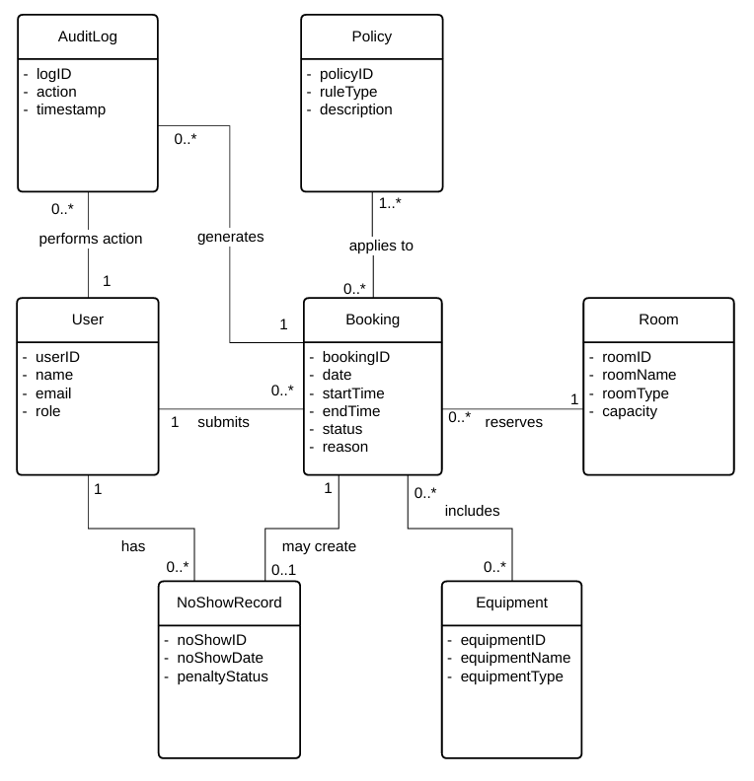
5.2 Entity-relationship diagram (ERD) / domain model

5.3 Data retention, deletion, and auditability

The system stores the data needed to manage room and equipment bookings. This includes user
information, room information, equipment information, booking requests, booking status, no-show
records, and audit logs. The system stores this data to support booking approval, prevent conflicts,
handle no-shows, and keep a clear history of system actions.

Retention:

- The system should keep active booking records as long as the booking is pending, approved, or still needed by the user or administrator. After a booking is completed, cancelled, rejected, or marked as a no-show, the system should keep the record for one academic year. This allows the facilities administrator to review previous bookings, check repeated no-shows, solve disputes, and understand past room and equipment usage.

- The system should also keep no-show records for one academic year because they may affect user penalties or temporary booking restrictions. The system should keep audit logs for one academic year because they provide evidence of important actions in the system, such as approvals, rejections, cancellations, and changes to bookings.

Deletion:

- The system may archive or delete old booking records after one academic year if they are no longer needed. The system should not store unnecessary personal information. User data should only be stored if it is needed for booking, approval, no-show handling, or audit purposes.

- If a user account is removed, the system should delete unnecessary personal information. However, the system may keep some limited audit information to preserve the history of old bookings and administrative actions. The system should not delete active bookings, pending requests, no-show records under review, or audit logs that are still needed for accountability.

Auditability:
- The system should keep an audit log for all important actions. Each audit log should record the action, the user who performed the action, the related booking, and the timestamp. The system should log when a booking request is created, approved, rejected, modified, cancelled, marked as no-show, or when a penalty is applied.

- The audit log helps the facilities administrator track what happened in the system. It also helps solve problems because the administrator can see who made each change and when it was made. This supports accountability and makes the booking process more reliable and transparent.

6. UI Prototype and Usability Evaluation

6.1 Prototype link
- Figma Link:
https://www.figma.com/design/wywsUK3Lp4815LHvNMfuIM/Project?node-id=0-1&m=dev&t=f29dk7ybKl9GWvKs-1

6.2 Key screens and states

- Login Screen
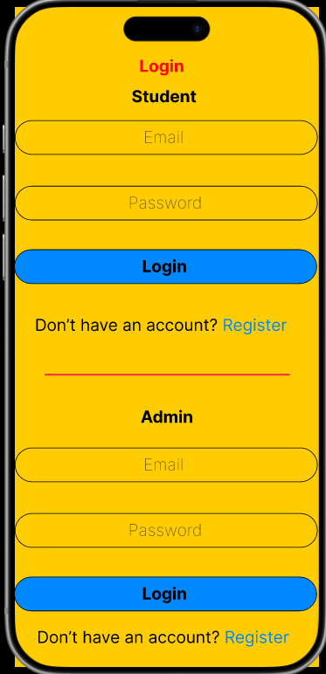
Login Screen
Description: This screen allows users to log into the system by entering their email and password. It is the entry point to access the booking features.

- Search Screen
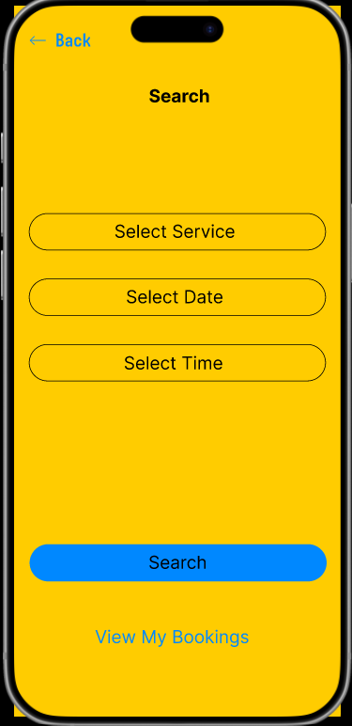
Search Screen
Description: This screen allows users to search for available rooms or equipment by selecting date, time, and resource type. It helps users find suitable options

- Result Screen
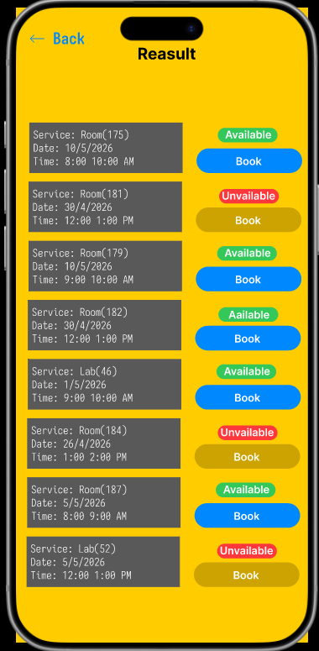
Result Screen
Description: This screen displays the available rooms or equipment based on the user’s search criteria. Users can review options and choose a suitable one to proceed with booking.

- Confirmation Screen

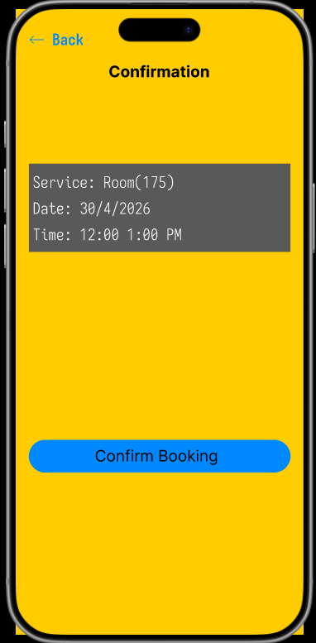
Confirmation Screen
Description: This screen displays the booking details, including the room, date, and time, allowing the user to review the information before confirming. The user can click the “Confirm Booking” button to complete the booking process.

- My Booking Screen
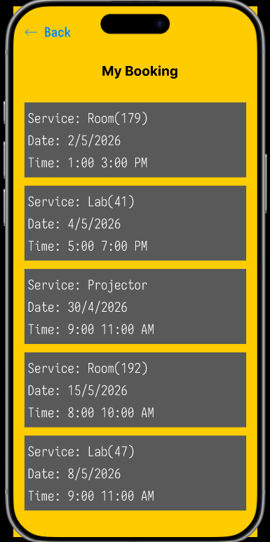
My Booking Screen
Description: This screen displays all the user’s current and past bookings. It allows the user to view booking details
- Display Screen
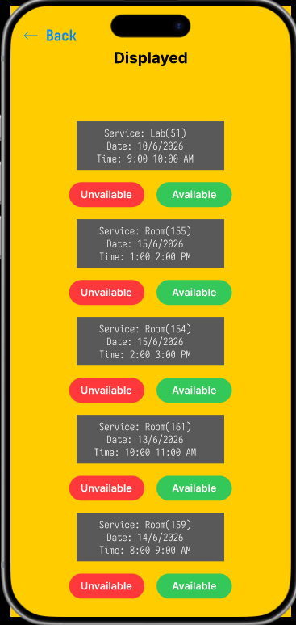
Display Screen
Description: This screen allows the system administrator to control the availability of rooms or equipment by setting them as available or unavailable. This helps in organizing resources and preventing bookings during unavailable periods.

7. Appendix

7.1 References
- Reference 1: Lecture slides and materials provided in CpE 371 – Software Engineering and Development course.
- Reference 2: StarUML Official Website
- Reference 3: Figma official documentation.

7.2 Project Management

Work Breakdown Structure
Task No. | Task Name | Duration | Start Date | Finish Date | Predecessor | Resource / Responsible | Deliverable
1 | Project proposal and topic selection | 4 days | 2026-03-27 | 2026-03-31 | - | Team | Approved project idea
2 | Define project scope and objectives | 4 days | 2026-03-27 | 2026-03-31 | 1 | Team | Scope and objectives section
3 | Identify stakeholders and constraints | 4 days | 2026-03-27 | 2026-03-31 | 2 | Naif Alhariji | Stakeholder and constraints section
4 | Write functional requirements | 4 days | 2026-03-27 | 2026-03-31 | 3 | Yousof Dardir | Functional requirements section
5 | Create use case model | 4 days | 2026-03-27 | 2026-03-31 | 4 | Yousof Dardir | Use case diagrams and descriptions
6 | Write non-functional requirements | 3 days | 2026-04-10 | 2026-04-12 | 4 | Yousof Dardir | NFR section
7 | Create domain overview | 16 days | 2026-04-10 | 2026-04-26 | 5 | Yousef Alotaibi | Domain overview
8 | Draw ERD / domain model | 16 days | 2026-04-10 | 2026-04-26 | 7 | Yousef Alotaibi | ERD diagram
9 | Write data retention and auditability section | 16 days | 2026-04-10 | 2026-04-26 | 8 | Yousef Alotaibi | Data retention section
10 | Design UI prototype screens | 16 days | 2026-04-10 | 2026-04-26 | 6 | Naif Alhariji | Prototype screens
11 | Conduct usability evaluation | 16 days | 2026-04-10 | 2026-04-26 | 10 | Team | Usability findings table
12 | Add references and project management evidence | 9 days | 2026-04-17 | 2026-04-26 | 11 | Yousof Dardir | References, WBS, Gantt, meetings
13 | Final review and formatting | 9 days | 2026-04-17 | 2026-04-26 | 12 | Team | Final SRS document
14 | Final submission | 1 day | 2026-04-26 | 2026-04-26 | 13 | Team | Submitted project

Gantt Chart
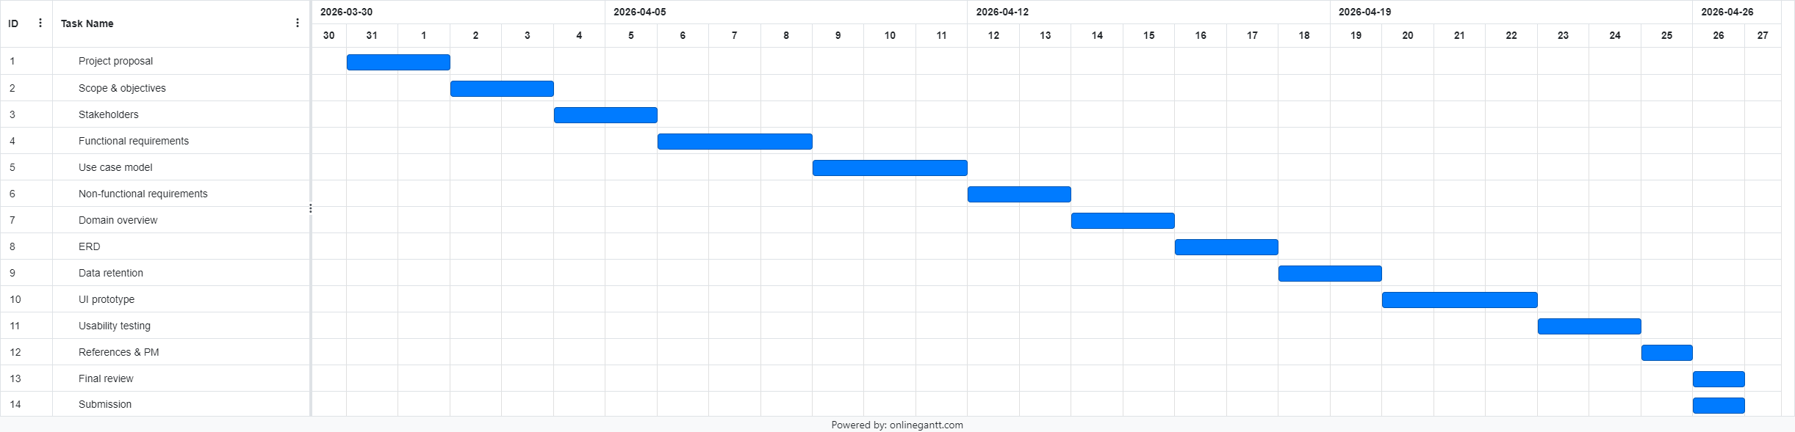
Link
https://github.com/YousofDardir/Software-Project
The Gantt chart illustrating the project schedule is included and available in the repository link provided above along with the report submission.

Team Meetings
Meeting 1
Team Name: | Campus Booking System Team | Date: | 2026-03-27
Start Time: | 6 PM | Finish Time: | 7 PM

Members Present: | Yousof Dardir  Yousef Alotaibi  Naif Alhariji
Members Excused: | None
Members Tardy: | None
Members Absent: | None

Summary of meeting 1
The team discussed the project idea and agreed to develop a Campus Room & Equipment Booking System. The scope of the system was defined, including booking rooms and equipment, approval by administrators, and handling no-shows. Responsibilities were distributed among team members, and initial work on the requirements section was planned.

Team Member | Assigned Tasks | Start Date | Due Date
Yousof Dardir | Section 3 | 2026-03-27 | 2026-03-31
Yousef Alotaibi | Section 1 | 2026-03-27 | 2026-03-31
Naif Alhariji | Section 2 | 2026-03-27 | 2026-03-31

Meeting 2
Team Name: | Campus Booking System Team | Date: | 2026-04-10
Start Time: | 6 PM | Finish Time: | 7 PM

Members Present: | Yousof Dardir  Yousef Alotaibi  Naif Alhariji
Members Excused: | None
Members Tardy: | None
Members Absent: | None

Summary of meeting 2
The team reviewed the functional requirements and finalized the main system features, including booking management, admin approval, and no-show handling. Use case diagrams were discussed and completed. The team also started working on the non-functional requirements and domain model.

Team Member | Assigned Tasks | Start Date | Due Date
Yousof Dardir | Section 4,7 | 2026-04-10 | 2026-04-12
Yousef Alotaibi | Section 5 | 2026-04-10 | 2026-04-12
Naif Alhariji | Section 6 | 2026-04-10 | 2026-04-12

Meeting 3
Team Name: | Campus Booking System Team | Date: | 2026-04-17
Start Time: | 6 PM | Finish Time: | 7 PM

Members Present: | Yousof Dardir  Yousef Alotaibi  Naif Alhariji
Members Excused: | None
Members Tardy: | None
Members Absent: | None

Summary of meeting 3
The team continued working on unfinished work. Final corrections and formatting were applied. The Gantt chart, WBS, references, and repository link were added. The team confirmed that the project is ready for final submission after all sections have been added correctly and reviewed.

Team Member | Assigned Tasks | Start Date | Due Date
Yousof Dardir | Section 7, Final corrections and Formatting | 2026-04-17 | 2026-04-26
Yousef Alotaibi | Section 5, Reviewing | 2026-04-17 | 2026-04-26
Naif Alhariji | Section 6, Reviewing | 2026-04-17 | 2026-04-26

All meeting minutes documents will be submitted separately along with this report
Link
https://github.com/YousofDardir/Software-Project

